LCMS – Office of National Mission Witness and Outreach - Nurturing Spiritual Care

$ 3,500

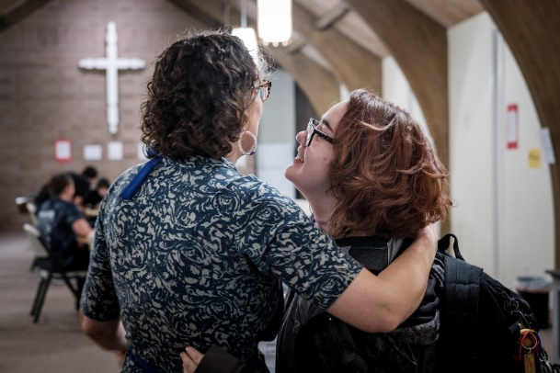
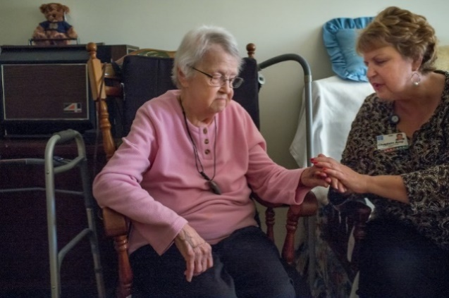

“Nurturing Spiritual Care” provides pastors and other church leaders with an effective resource for equipping members to share the love of Jesus with hurting and broken people both within and outside of the church. Showing the love of Jesus through the compassionate care of suffering people opens doors to speaking the love of Christ to those who do not know Jesus as their Healer and Savior.
In a single resource, The LCMS Office of National Mission – Witness and Outreach program “Nurturing Spiritual Care” equips God’s people for both reaching the lost and encouraging the faithful through compassionate and personal human care.

2022-2024 Biennium – LWML Washington-Alaska District

